ONLINE E-BOOK PURCHASE SYSTEM

By:

**Darshan Jitendra Kumar Jain**.

(BSC(CA & IT) SEMESTER V)

## Exam No: -

# Submitted as

## Partial fulfillment of

**BSC(CA & IT)**  **Degree**

**2022 – 2023**

# Natubhai V. Patel College of Pure and Applied Sciences

**THE CHARUTAR VIDYA MANDAL UNIVERSITY**

### Natubhai V. Patel College of Pure and Applied Sciences

**Constitute college of CVM University**

### CERTIFICATE

**Date: -**

This is to certify that **Darshan Jitendra Kumar Jain** of **BSC(CA & IT)** – SEM – V **(Seat No.___________)** has worked on project entitled **ONLINE E-BOOK PURCHASE SYSTEM** from 18th July 2022 to 20th October 2022. This **(101150508)** is in-house project course of three credits.

He / She was regular in his work and developed around **70 hours** for the project including analysis and design. He / She has completed the project satisfactorily.

Dr. Monika Patel

Mr. Mayur Patel

#### Head of Department Project Guide

**Acknowledgement**

Project work has been the most practical and exciting part of my learning experience, which would be an asset for me for my future career.

No system is created entirely by an individual. Many people have helped me to create this system and each of their contribution has been valuable.

Proper organization of concept and analysis of the system is due to keen interest and helping hand of my teachers and colleagues.

I am deeply thankful to the principal **Dr. Basudeb Bakshi** for holding my thoughts and vision towards all the subjects, I was studying till date.

I am deeply thankful to **Mr. Mayur Patel**, the head of Computer Science Department, who was a constant source of inspiration not only during this project, but also through this year.

Most sincere thanks to project guide **Dr. Monika Patel**, for her kind co-operation and who has always been guiding, encouraging and motivating me throughout the project.

|  |  |  |
| --- | --- | --- |
| **PROJECT INDEX** | | |
| **Sr. #** | **Description of Topic** | **Page #** |
| 1 | Title Page of Project | - |
| 2 | College Certificate | - |
| 3 | Acknowledgement | - |
| 4 | Index | - |
| 5 | Introduction to The Project | 1 |
| 6 | Scope of Work | 2 |
| 7 | An Existing System | 3 |
| 8 | Need of proposed System | 4 |
| 9 | Feasibility Study | 5 |
| 10 | System Features | 6 |
| 11 | Hardware and Software | 7 |
| 12 | Data Flow Diagram / OOAD / UML | 8 |
| 13 | Database Layout / File Layout | 14 |
| 14 | Design of Input Screens | 18 |
| 15 | Design of Output Screens & Reports | 18 |
| 16 | Limitations | 35 |
| 17 | Conclusion | 36 |

**Introduction to The Project**

The Project “Online E-Book Purchase System” is an online website where user can purchase and read eBooks.

The main objective of the project is to create an online e-book store that allows users to search and purchase an e-book based on title. The selected e-books are displayed in a tabular format and the user can buy their books online through debit card payment. The Administrator will have additional functionalities when compared to the common user.

It has two modules -

1. Admin.
2. User.

Online E-Book Purchase System is an online web application where user can Buy E-Books, search E-Books. E-Books are arranged in categories.

Admin has all the Access of data. Admin can delete eBook. Admin can view user list and dashboard for small information. Admin can generate user’s e-book purchase report.

It has simple interface and Easy to use GUI (Graphical User Interface), hence any user with minimal knowledge of operating a system can use this web application.

**Scope of Work**

* The Online E-Book Purchase System is an easy to maintain, ready to run, scalable, affordable and reliable and cost saving tool.
* This System can be used by any user who have the basic knowledge of Internet and a browser. All you need is a reliable and fast high speed Internet connection, account and subscription.
* It does not require any educational level, experience and technical expertise in computer field but it will be a good use if user has the good knowledge of how to operate a computer.
* User can use this system anywhere and run on any platform. User can access this system with their mobile browser or desktop browser.
* It helps publisher to sell their e-books easily.

**An Existing System**

Things going manually like going to the book store from your home to buy a book.

You have to go to the store every time when a new need new book for reading or new book is published.

To Buy a Book from the bookstore you have to wait a while for other customer to make their payment and sometimes the book you need to read is not available at book store or out of stock. Sometimes hard copy of the book is out of stock on online store and it takes time to deliver it to your home.

**Need of Proposed System**

Online E-Book Purchase System has redefined the future of reading books. E-Books are getting more popular. With a single click, one can access any choice of e-Books in a way that the traditional Book Store can’t provide.

It’s eliminating the need to purchase hard copy of a book. It reduces time between purchasing a book and reading a book. Further it takes up Storage disk space, ranging from 5MB to 1GB, depending on the number of E-Books and size of E-Books.

You can find all the books at one place. This system provides multi-device access, so you can use any of your devices, making your book reading experience a matter of personal choice, preference and convenience.

**Feasibility Study**

**Operation Feasibility**

The project has been developed in such a way that it becomes very easy even for a person with little computer knowledge to operate it. As this project is user friendly version there is not much training required for the people to use. This project is not only making the task of administrator easy but it also reducing the time that is taken otherwise. So, we can say that this project is operationally feasible.

**Economic Feasibility**

An economic feasibility analysis is a criterion for determining the final market position of a website. More commonly known as cost/benefit analysis. Good economic feasibility analysis is helpful for project implementation and management. In this system development process, the technologies used, from the database to the development tools, and then to the server are free, so the cost of the development of the system is only invested in time and effort, therefore, the system is economically feasible.

**Technical feasibility**

The technical feasibility in the proposed system deals with the technology used in the system. It deals with the hardware and software used in the system whether they are latest technology or not. The System use windows platform it can run on any Operating System which has browser, Front-End Technology is HTML, CSS and for Back-End PHP and MYSQL Database Sever is used. Thus, this System is technically feasible.

**System Features**

* Manage the information of E-Books, Users, Book Category and Book Purchase Transactions.
* Provides the searching facilities in user module to search e-books from a large list.
* Purchase and read E-Books.
* The System store eBooks and users’ information.
* The System Upload E-Book PDF file and E-Book Thumbnail image file to the server.
* Generating reports according to selected field for search.
* Provides purchase system to buy an e-book.
* Provide Cart System to buy multiple eBooks at a time.
* Latest books for each genre.

**Hardware and Software**

Minimum Hardware Requirements:

Processor: Intel i3 (1GHz) and above.

Hard disk: 10GB.

RAM: 2GB.

Software Requirements:

Operating System: Windows, Linux, Mac, Android, IOS.

Browser: Google Chrome, Microsoft Edge, Mozilla Firefox.

Web Server: WAMP.

Front End Tool: PHP.

Back End Tool: MYSQL.

**Data Flow Diagram**

**Context Level : -**

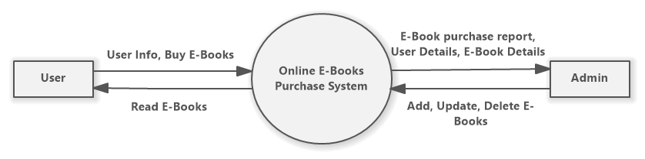

**User Zero Level :-**

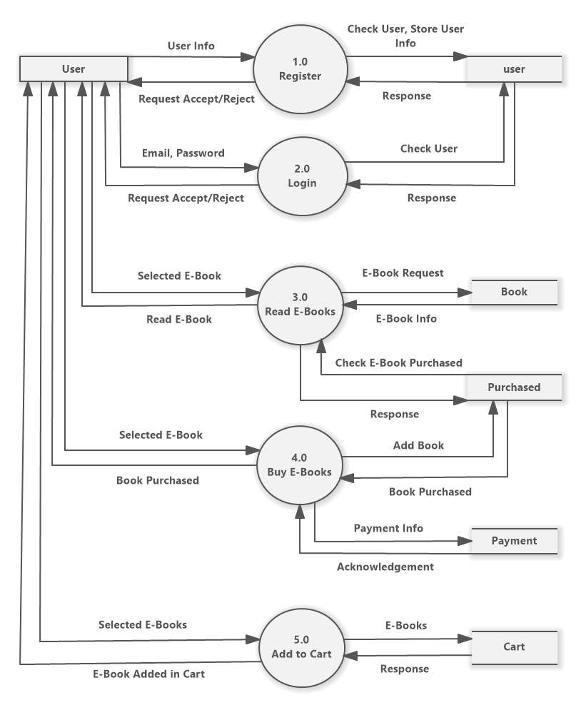

**Admin Zero Level :-**

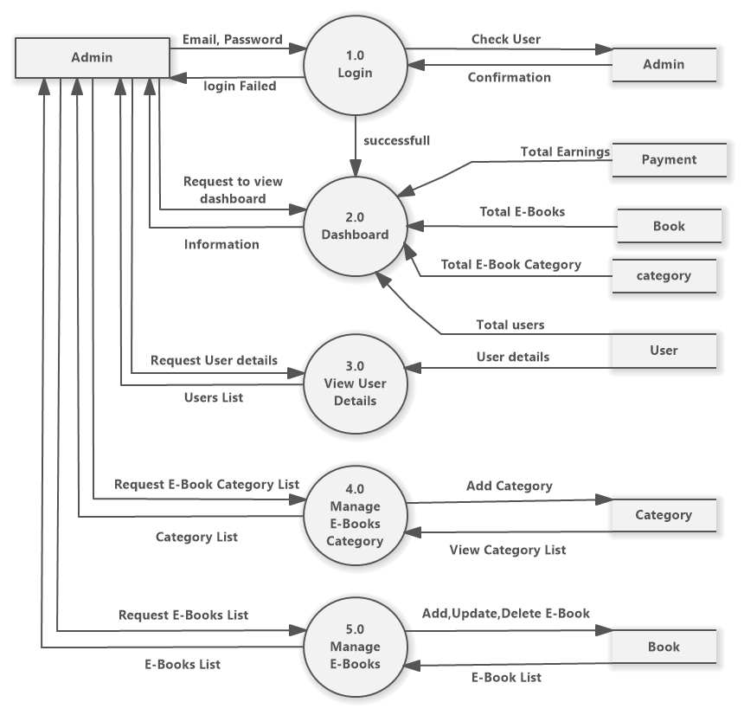

**User First Level for Registration Process 1.0: -**

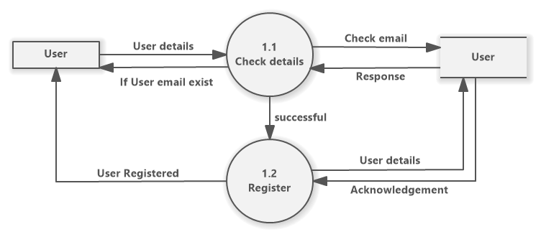

**User First Level for Login Process 2.0: -**

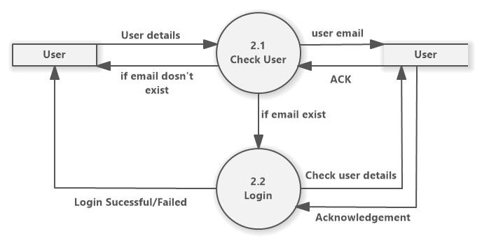

**User First Level for Add to Cart Process 5.0 :-**

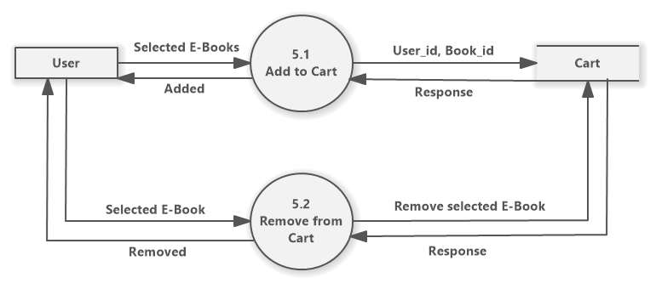

**Admin First Level for Dashboard process 2.0 : -**

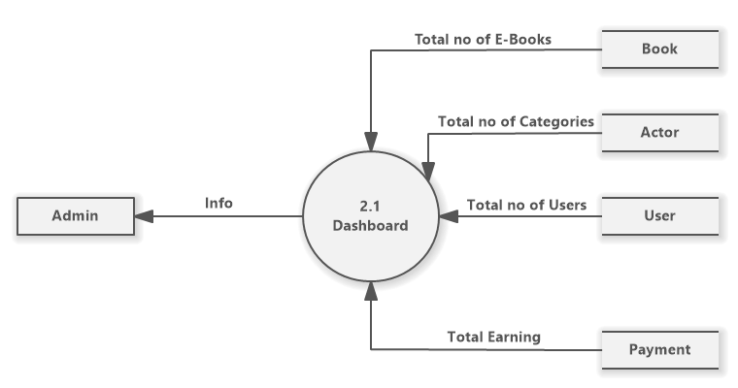

**Admin First Level for Manage E-Book process 5.0 :-**

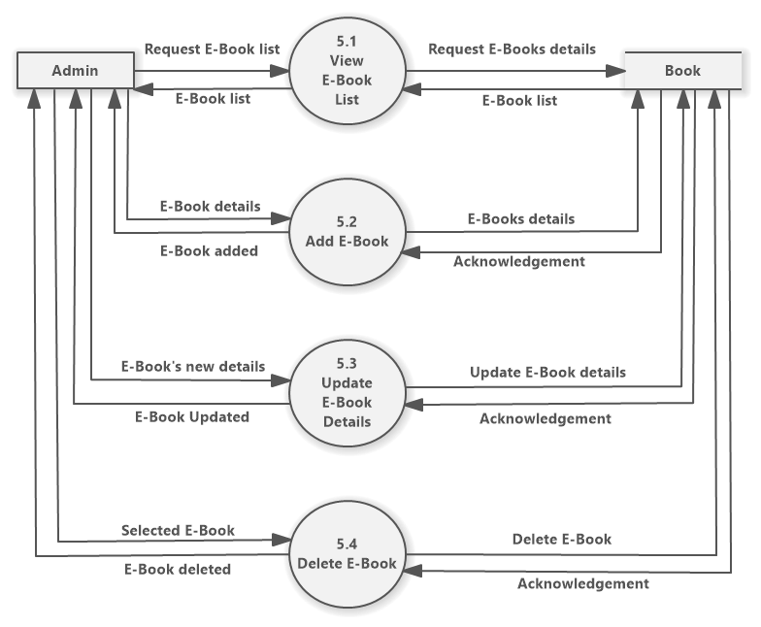

**Database Layout**

**user :-**

|  |  |  |  |  |  |
| --- | --- | --- | --- | --- | --- |
| **S. No.** | **Field** | **Datatype** | **Null** | **Constraints** | **Description** |
| 1 | id | Int (11) | No | primary | User id |
| 2 | name | Varchar (50) | No |  | Name of the user |
| 3 | email | Varchar (100) | No |  | Email address of user |
| 4 | password | Varchar (15) | No |  | Password of the user |

**admin :-**

|  |  |  |  |  |  |
| --- | --- | --- | --- | --- | --- |
| **S. No.** | **Field** | **Datatype** | **Null** | **Constraints** | **Description** |
| 1 | id | Int (11) | No | primary | Admin id |
| 2 | name | Varchar (50) | No |  | Name of the admin |
| 3 | email | Varchar (100) | No |  | Email address of admin |
| 4 | password | Varchar (20) | No |  | Password of the admin |

**payment :-**

|  |  |  |  |  |  |
| --- | --- | --- | --- | --- | --- |
| **S. No.** | **Field** | **Datatype** | **Null** | **Constraints** | **Description** |
| 1 | id | Int (11) | No | primary | Payment id |
| 2 | user_id | Int (11) | No |  | Id of the user |
| 3 | name | Varchar (50) | No |  | Name of user |
| 4 | email | Varchar (100) | No |  | Email of the user |
| 5 | amount | Int (11) | No |  | Amount paid by user |
| 6 | paymentdate | date | No |  | Date of the payment |

**book :-**

|  |  |  |  |  |  |
| --- | --- | --- | --- | --- | --- |
| **S. No.** | **Field** | **Datatype** | **Null** | **Constraints** | **Description** |
| 1 | book_id | Int (11) | No | primary | Book id |
| 2 | name | Varchar (50) | No |  | Name of the book |
| 3 | author | Varchar (50) | No |  | Name of the author |
| 4 | publisher | Varchar (50) | No |  | Name of the publisher |
| 5 | publishdate | Date | No |  | Published date of the book |
| 6 | language | Varchar (50) | No |  | Language of the book |
| 7 | category | Int (11) | No |  | Category Id |
| 8 | price | Int (11) | No |  | Price of the book |
| 9 | description | Varchar (100) | No |  | Description of the book |
| 10 | booklink | Varchar (150) | No |  | Link of the book |
| 11 | thumbnail | Varchar (150) | No |  | File path of thumbnail image |

**cart :-**

|  |  |  |  |  |  |
| --- | --- | --- | --- | --- | --- |
| **S. No.** | **Field** | **Datatype** | **Null** | **Constraints** | **Description** |
| 1 | id | Int (11) | No | primary | Cart id |
| 2 | user_id | Int (11) | No |  | Id of the user |
| 3 | book_id | Int (11) | No |  | Id of the added book |

**category :-**

|  |  |  |  |  |  |
| --- | --- | --- | --- | --- | --- |
| **S. No.** | **Field** | **Datatype** | **Null** | **Constraints** | **Description** |
| 1 | cat_id | Int (11) | No | primary | Category id |
| 2 | cat_name | varchar (50) | No |  | Name of the category |

**purchased :-**

|  |  |  |  |  |  |
| --- | --- | --- | --- | --- | --- |
| **S. No.** | **Field** | **Datatype** | **Null** | **Constraints** | **Description** |
| 1 | id | Int (11) | No | primary | purchased id |
| 2 | user_id | Int (11) | No |  | Id of the user |
| 3 | book_id | Int (11) | No |  | Id of the purchased book |

**Design of Input/Output Screens**

1. Index Page

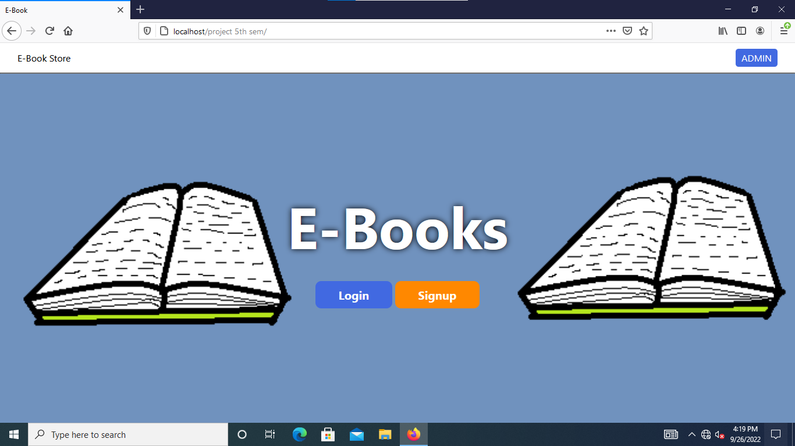

* This is the index page of Online E-book Purchase System.
* This page shows basic details of website.
* Navigation bar contain website name, Admin button.
* Signup button to create a new account on Sign in page.
* Admin button to login to admin.
* Login button to go to login page of user.

2. User Sign in Page

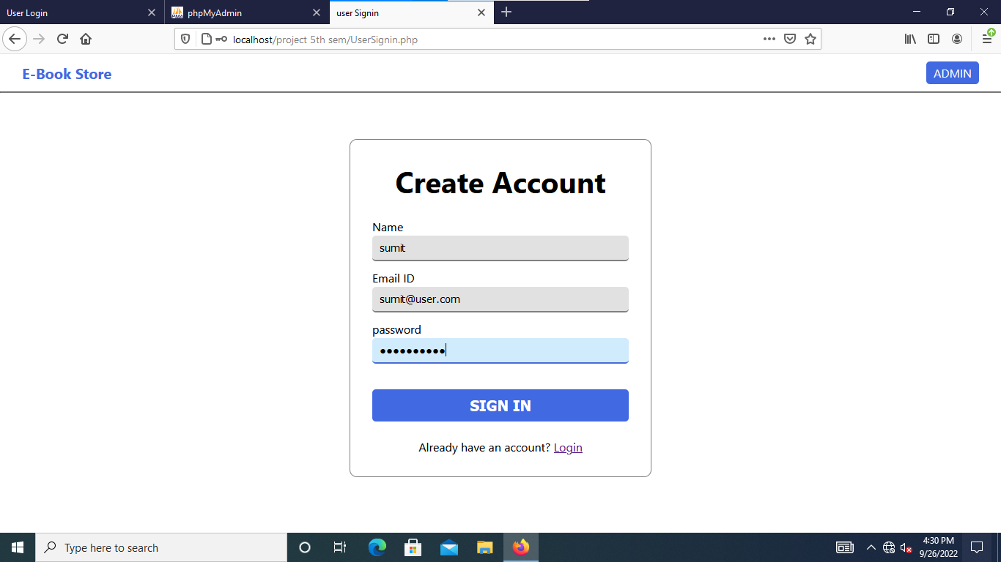

* User sign in page to create a new account.
* Validations -

1. Check email id already exist or not.
2. Password length must be in between 8 to 16.

* Admin button to login to admin.
* Login button to go to login page for user.
* Sign in button to submit user details and create an account.

3. User Login Page

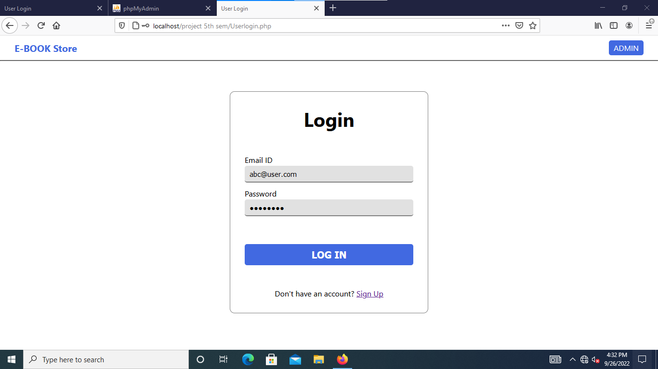

* User Login page for login to the User Home Page.
* Validations -

1. Check email id exist or not.
2. Password length must be in between 8 to 16.

* Admin button to go to login page of the admin.
* Sign Up button to go to sign in page for user.
* Login button to login to the User Home Page.

4. User Home Page

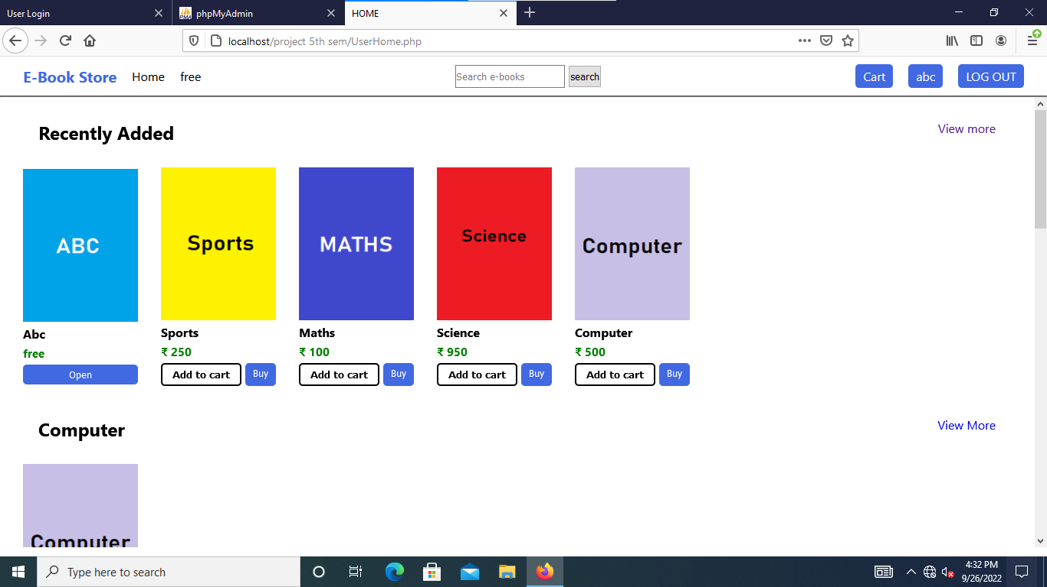

* Recently Added E-books list.
* Search bar for searching books.
* Free button in navigation bar to read free available books.
* To view User Profile, click on your username on top right corner.
* Cart button to view cart page.
* Log out button to log out the user.
* Add to cart button add e-book to the cart.
* Buy button to go to payment page.

5. User Cart Page

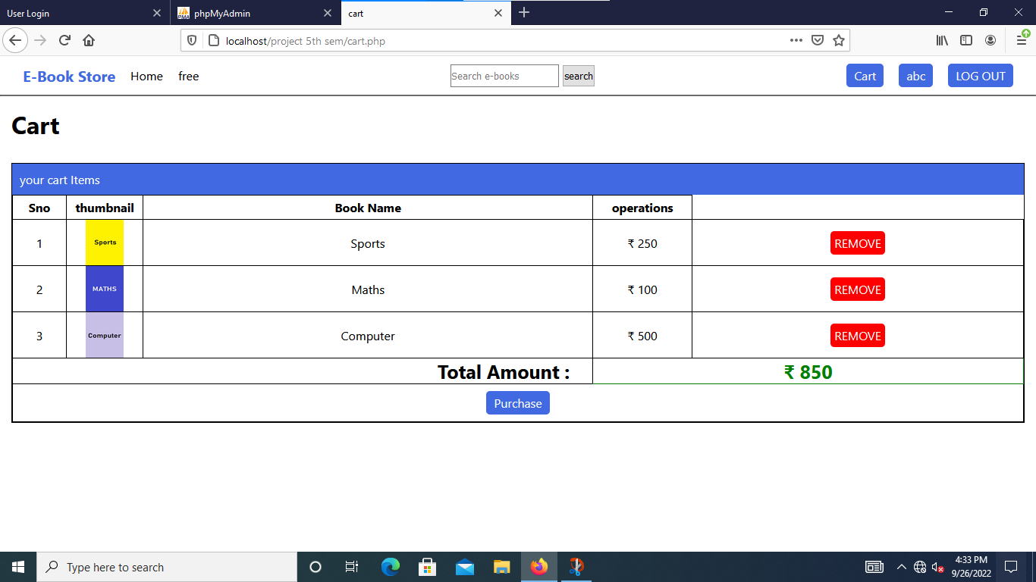

* Cart page of the user.
* Display all the books added in cart.
* Remove button to remove e-book from cart.
* Purchase button to make payment in payment page.

6. User Search Result page

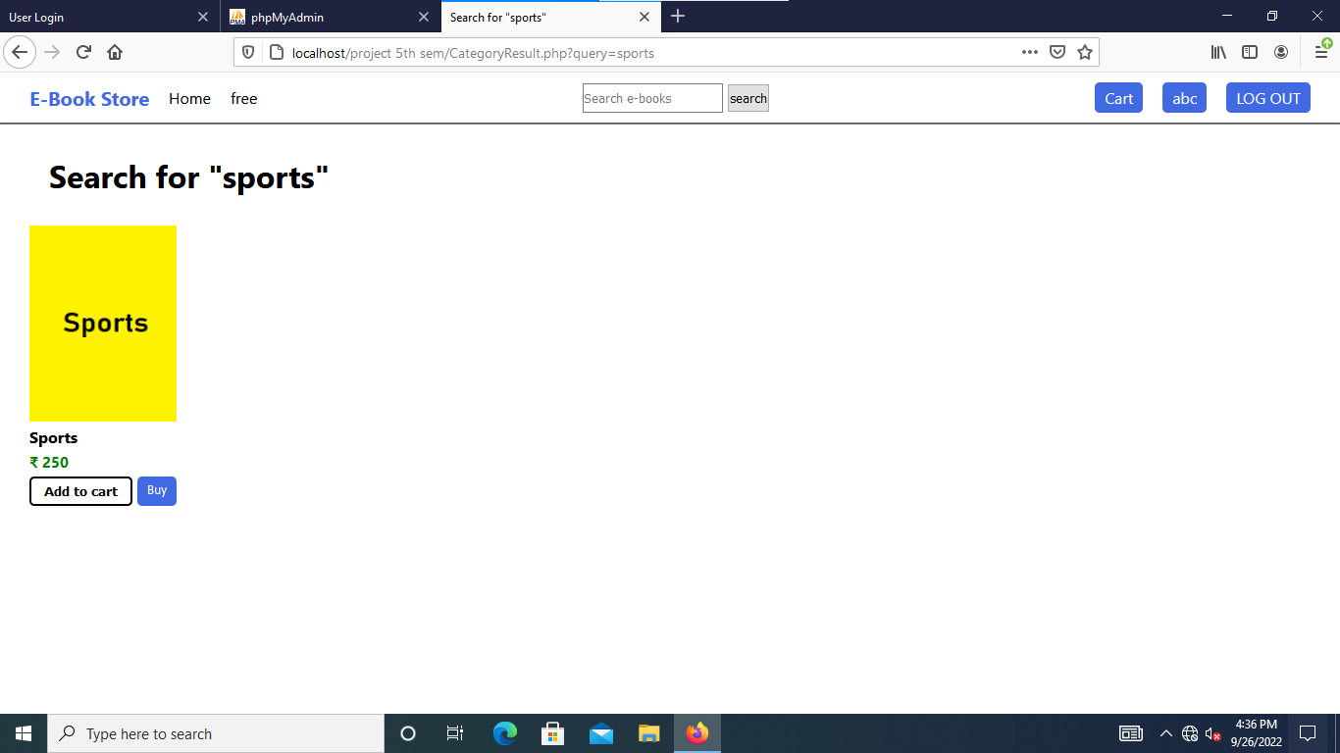

* User Searched results page.
* It shows all the e-books related to the search.
* Log out button to log out the user.
* Search bar for searching e-books.
* Home Button in navigation bar to go to home page of the user.
* Free button in navigation bar to read free available e-books.
* To view user profile, click on your username on top right corner.
* Click on book thumbnail to go to book detail page.

7. User Profile page

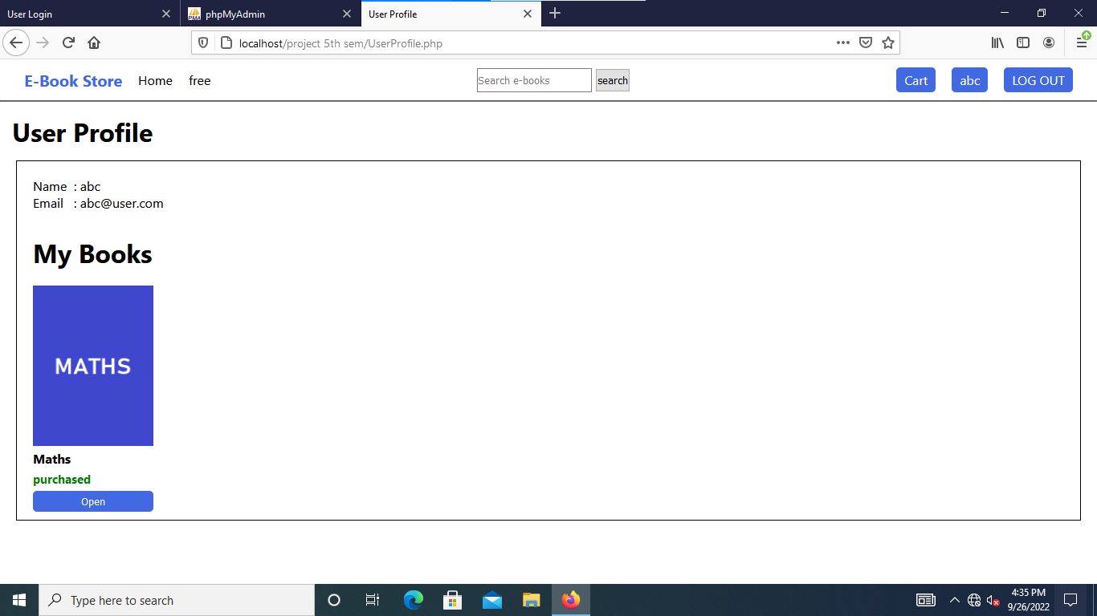

* User Profile page with booklist.
* Home Button in navigation bar to go to home page of the user.
* Shows user details like -

1. Name
2. Email

* Log out button to log out the user.
* All the books purchased by user shown in My Books section.
* Click on Open button to read book.

8. User Book detail Page

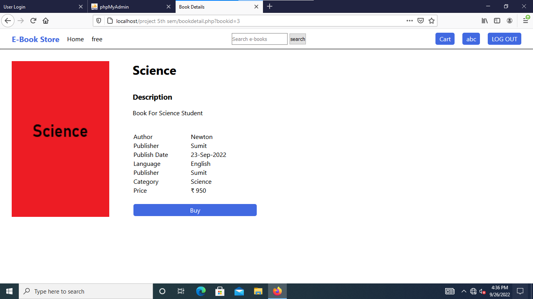

* Book detail page of the user.
* Display all the details of e-book.
* Buy Button to buy e-book.
* Log out button to log out the user.
* To view User Profile, Click on your username on top right corner.
* Search bar for searching e-books.

9. User Payment Page

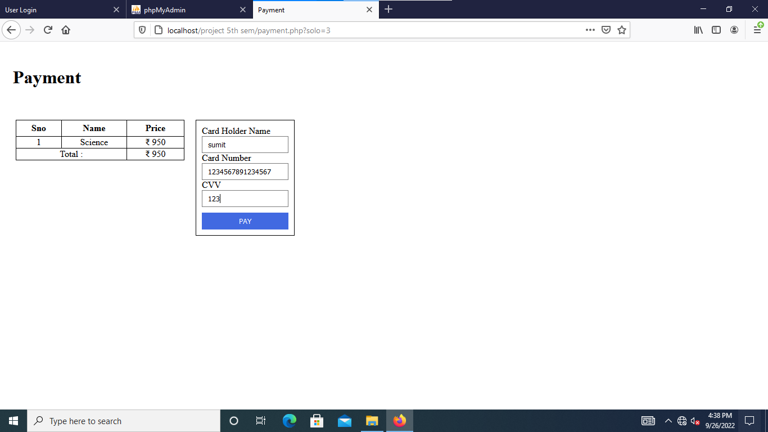

* User Payment page.
* Display selected e-books for purchase.
* Enter your debit card payment details.
* Pay button to pay amount and buy e-books.

10. Admin Login Page

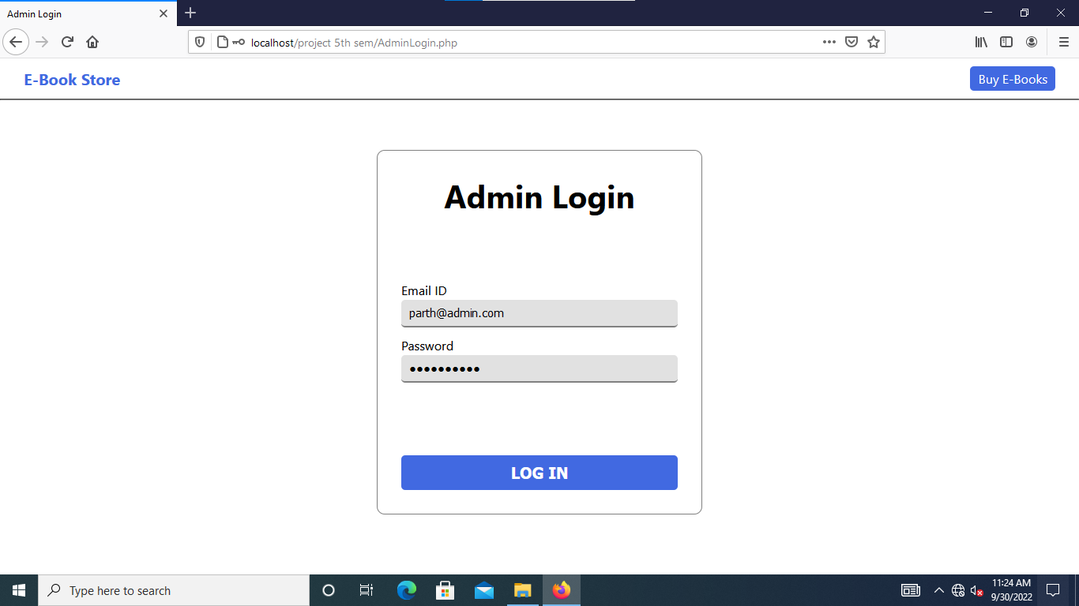

* Admin Login page for login to the Admin Home Page.
* Validations -

1. Check email id exist or not.
2. Password length must be in between 8 to 16.

* Buy E-books button to go to login page of the user.
* Login button to login to the Admin Home Page.

11. Admin Dashboard Page

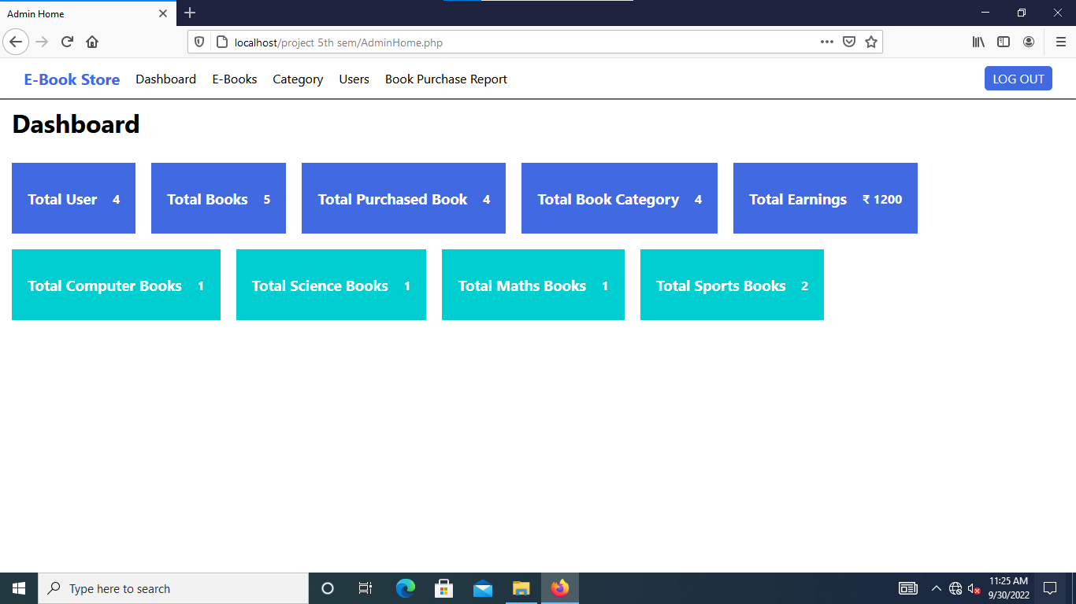

* All the basic details are available in Admin dashboard.
* Click on Card to view full detail list.
* Navigation Menu Items –

1. Dashboard – go to dashboard page.
2. E-Books – go to the e-book list page.
3. Category – go to the category list page.
4. Users – go to the user list page.
5. Book Purchase Report – go to the book purchase report page.

* It Shows details like –

1. Total User.
2. Total Books.
3. Total Purchased Book.
4. Total Book Category.
5. Total Earnings.

12. Admin E-Book list Page

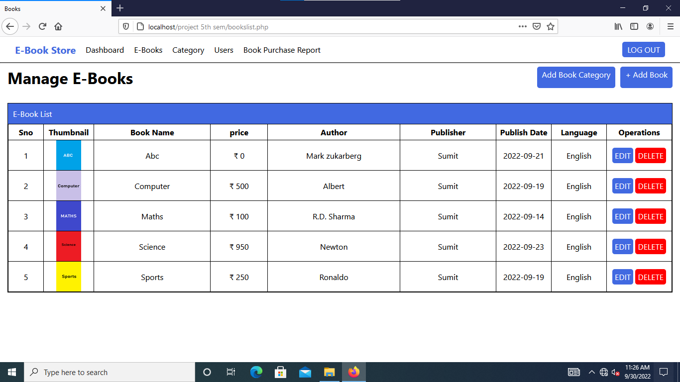

* All the E-Books listed here.
* It displays basic info of e-book like -

1. Book thumbnail.
2. Book name.
3. Price.
4. Author.
5. Publisher.
6. Publish Date.
7. Language.

* Add Book Button to add new e-book.
* Add Book Category button to view full category list.
* Edit button to update book details.
* Delete button to delete a book.
* Log out button to log out the admin.
* Navigation Menu Items –

1. Dashboard – go to dashboard page.
2. E-Books – go to the e-book list page.
3. Category – go to the category list page.
4. Users – go to the user list page.
5. Book Purchase Report – go to the book purchase report page.

13. Admin Add Book Page

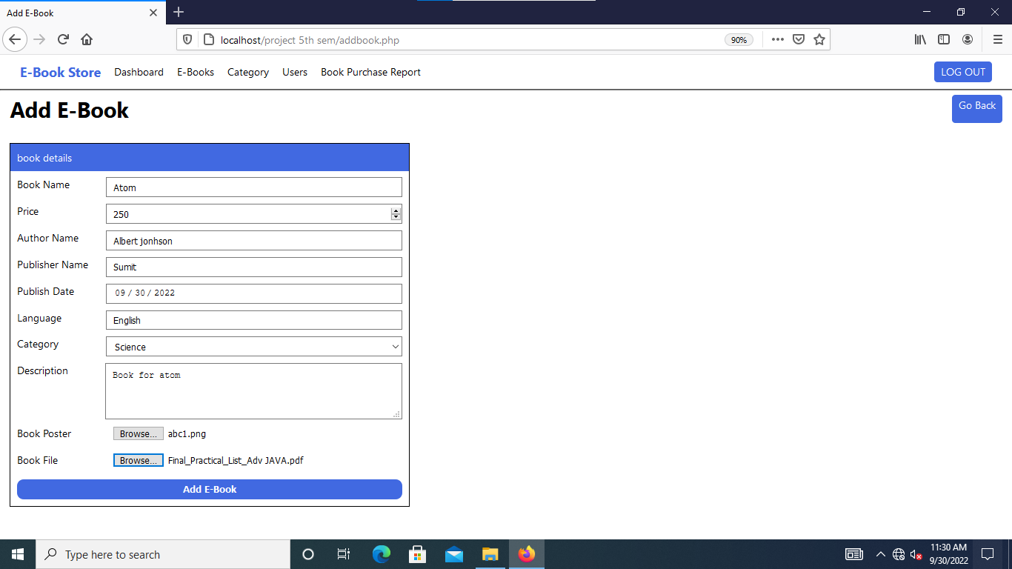

* Enter book details and click Add E-Book button to add book.
* Select book pdf file and book thumbnail image file for uploading to server.
* Log out button to log out the Admin.
* Go Back button to go to E-book list page.

14. Admin Update E-Book Page

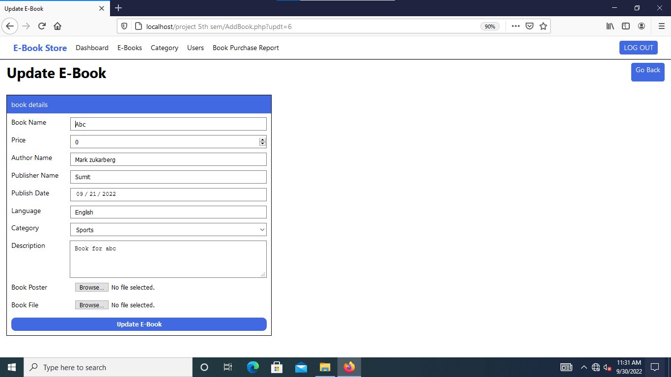

* Enter book’s new details and click Update E-book button to update e-book.
* Select book pdf file and book thumbnail image file for uploading to server.
* Log out button to log out the Admin.
* Go Back button to go to E-book list page.

15. Admin Book Category Page

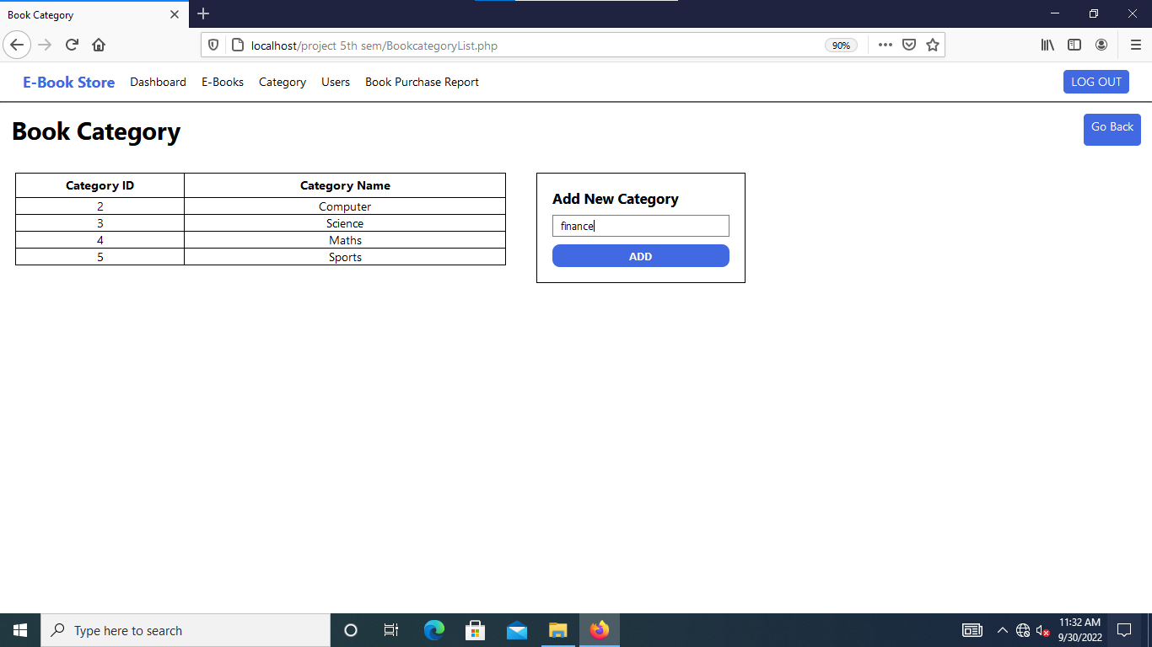

* Full list of available book category.
* Log out button to log out the Admin.
* Go Back button to go to Manage Movie Page.
* It shows details like –

1. Category id.
2. Category Name.

* Add button to add new book category.

16. Admin User List Page

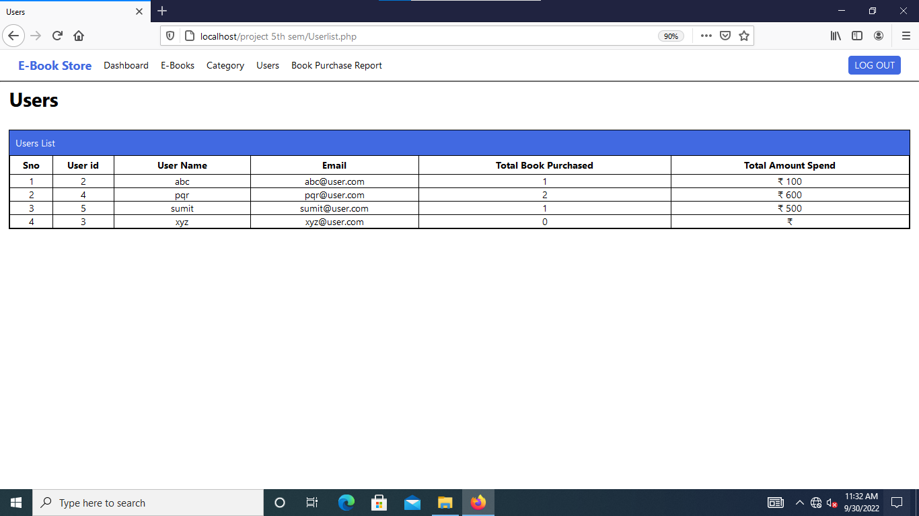

* All the details of user like –

1. User id.
2. User Name.
3. User Email.
4. Total Book Purchased.
5. Total Amount Spent.

* Navigation Menu Items –

1. Dashboard – go to dashboard page.
2. E-Books – go to the e-book list page.
3. Category – go to the category list page.
4. Users – go to the user list page.
5. Book Purchase Report – go to the book purchase report page.

17. Admin Book Purchase Report Page

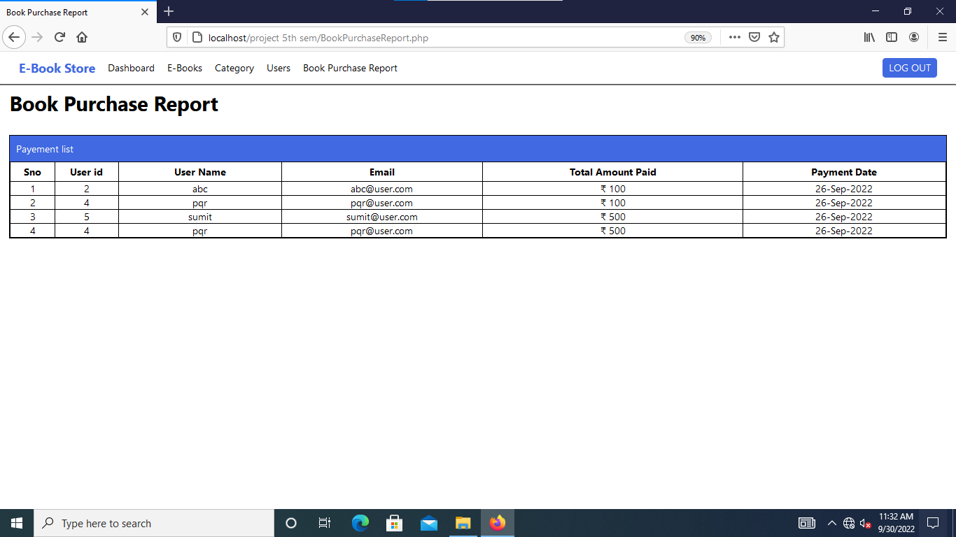

* List of all the transaction for purchasing e-books.
* Log out button to logout the admin.
* Display details like –

1. User id.
2. User Name.
3. Email.
4. Total Amount Paid.
5. Payment Date.

* Navigation Menu Items –

1. Dashboard – go to dashboard page.
2. E-Books – go to the e-book list page.
3. Category – go to the category list page.
4. Users – go to the user list page.
5. Book Purchase Report – go to the book purchase report page.

**Limitations**

* There is no email verification system for new user.
* There is no option for changing e-book language.
* The System does not have download option for an e-book.
* Time consuming as the uploading size of e-book increase.
* This system does not display the list of e-books purchased by user in admin panel.

**Conclusion**

This System is generally for those users who have interest in reading books.

This system enhances the speed of loading e-books, saving e-books details.

All the management of E-Books, Users and E-Books Category is done by Admin. No user can change or Add e-book details. Admin has all the access of data. Admin can view e-book list, user list and list all the transaction made by user.

User can buy e-books to read it online. Without purchasing user can only able to view book details and free available e-books. User can add books to their cart and remove from it.